**Project 1: Brand Website**

**Competitor Research**

The three different websites I looked at were: **Eneba.com, Game.es and Instant-gaming.com**

1. ***What is your first impression / first impulse?***

Above all, I think all of them try to catch people´s attention with the palette of colours used in their websites. In my opinion there is a kind of defined pattern for the websites of this type of niche as there is a clear and predominant use of a striking purple in these types of sites. The last one (“Instant-gaming.com”) uses orange and grey as their main theme but “surprisingly” there is a way to change the theme to a “Neon” theme. This “Neon” theme uses again purple. Finally, it should be noted that all these websites have two important things in common and it´s the use of a ton of images in their front pages and also the existence of a dropdown navbar menu.

1. ***Is the site organized and the navigation consistent?***

Yes, I think that they are very organized as you can move around the webs with ease. If you want to look for something you have a search bar at the top of the page or near it and you also have a marvellous dropdown menu with all the options, products and information you need. All the links and references in these pages are well positioned and very useful. Finally, I Think you can also easily navigate through these websites because there are almost no bulky elements within the user's field of vision.

1. ***Is there enough or too much content? Is the content interesting/relevant?***

I think that there is enough content in all of them. I do not believe that the amount of informative and visual material on its pages is abusive. I cannot say with precision the percentage of interesting or non-interesting material inside these web sites but I can make an approximation. In my opinion this percentage changes in on of them. In (“Eneba.com”) and (“Instant-gaming.com”) I can dare to say that there is an 90% of interesting or relevant elements while in the other one (“Game.es”) I could say that there is an 75% of interesting or relevant elements as the site is full of a lot of stuff, not always wanted by the user. I personally think this.

1. ***Does the appearance of the site connect with their product?***

Absolutely yes. Supposing that using a bright or flashy purple means that we are using a colour palette inspired by a “Neon” theme, this “Neon” theme is well connected and easily mentally linked by the user with technology, the future, a robotic kind of style, videogames, consoles, new generations…etc.

1. ***What stands out, both good and bad?***

As I said before, the use of the colours is the highlight of these pages. It stands out in a very striking and good way. The only bad thing I can say about these pages is perhaps the amount of unnecessary information or the number of bulky elements found in some sections and not in all websites nor sections.

1. ***Screenshots of relevant pages of these websites (“Front page”)***

* 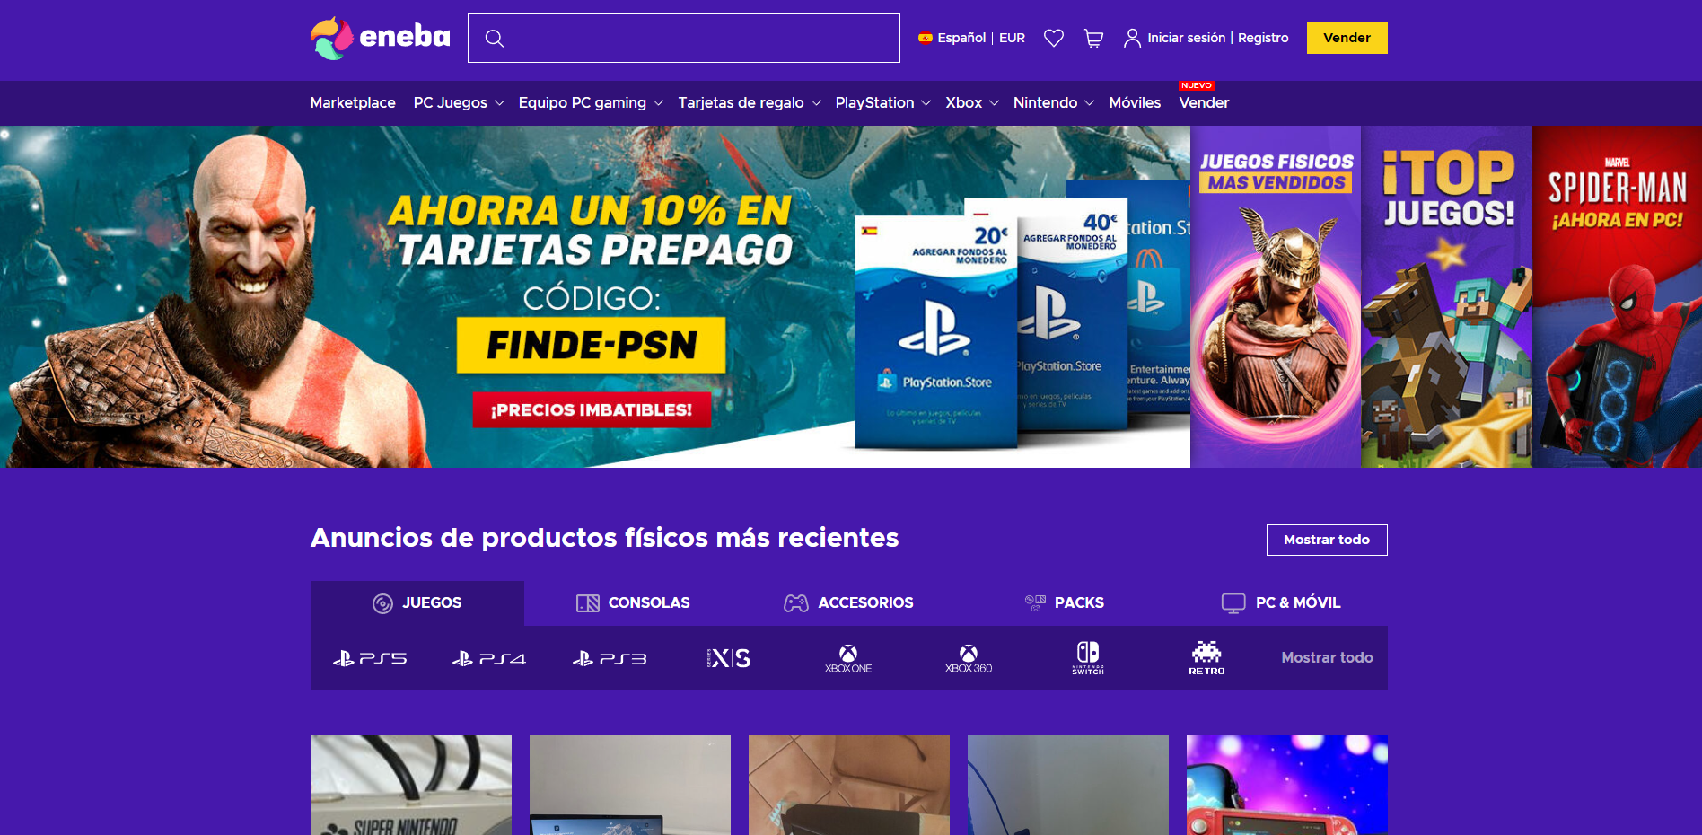**Eneba.com:**
* 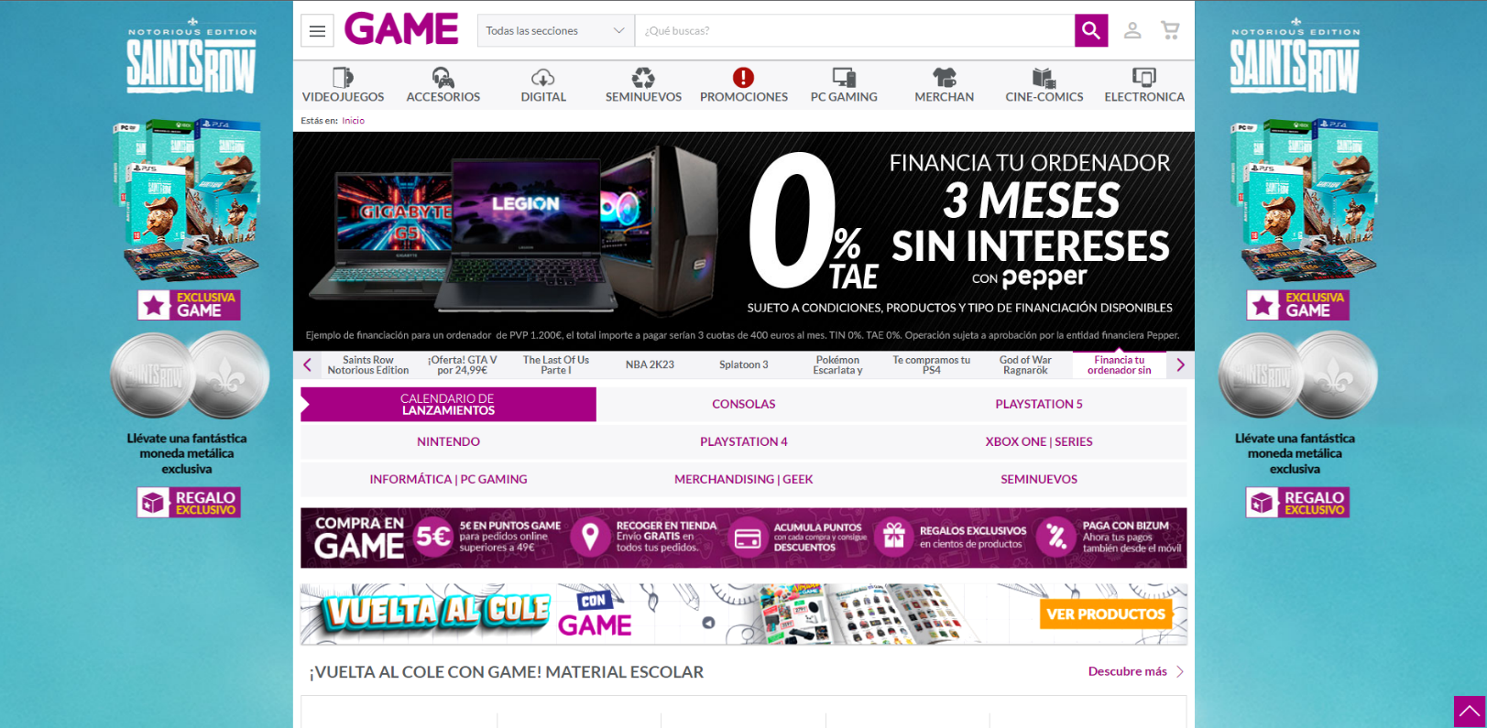**Game.es:**
* 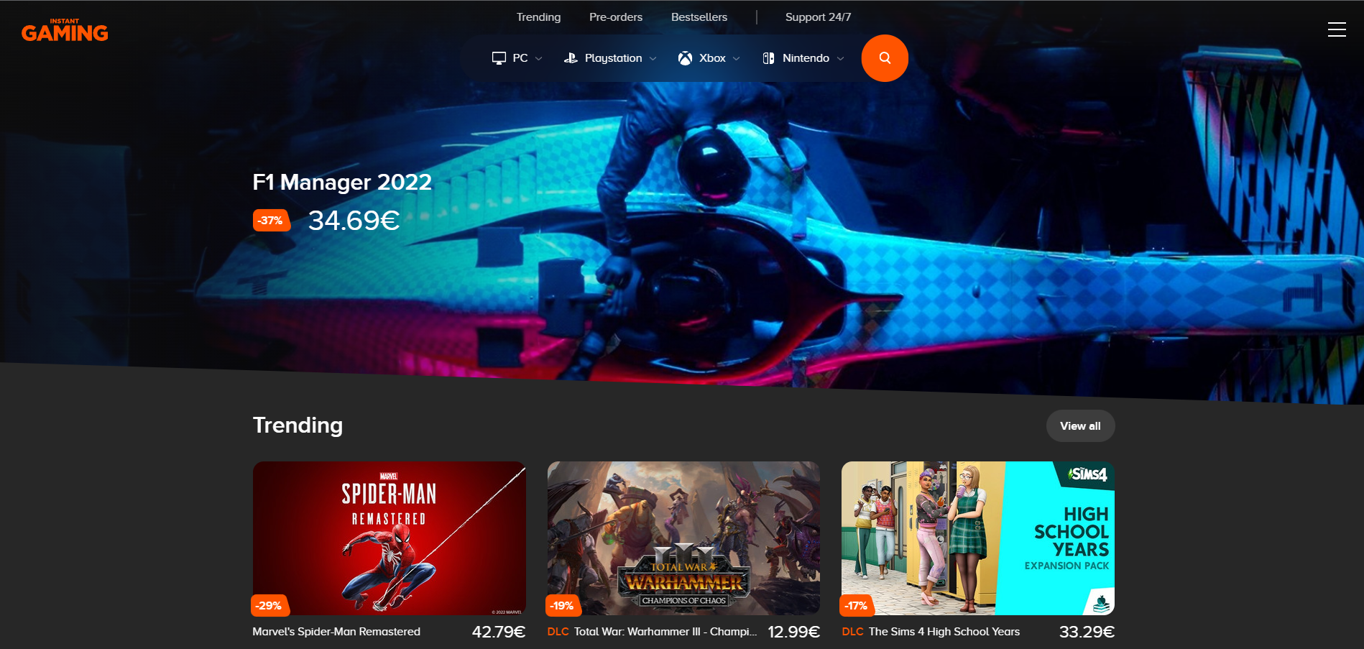**Instant-gaming.com (Main theme):**
* 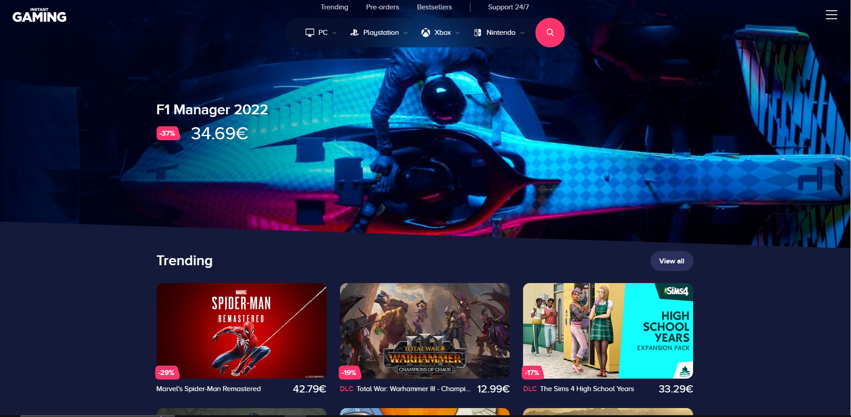**Instant-gaming.com (Neon theme):**

1. ***Persona***

For the “Persona” I started a research phase. I did a very small interview to 3 friends of mine who have previously purchased in these websites. The things I asked for were: Name? Age? Location? Hobbies? Bad experience with this type of websites? How our page could help them? Paint points?

Secondly, I wrote a rough draft of each person. Here are the results:

1. Person 1

* **Name:** Benito
* **Age:** 21
* **Location:** Madrid, Spain
* **Hobbies:** Going out with friends to parties and playing videogames (PC)
* **Bad experience:** His usual videogame store website doesn’t have accessories on sale
* **How our page could help:** Having sections for videogames, consoles but also for accessories. He Emphasizes the importance of the last one.
* **Pain points:** Lots of ads on the page, Bad navigation or structure.

1. Person 2

* **Name:** Pablo
* **Age:** 18
* **Location:** Madrid, Spain
* **Hobbies:** Playing videogames (PC-PS5) and playing football.
* **Bad experience:** Once, he had a bad experience with the costumer service as they talked to him in a very bad and rude way.
* **How our page could help:** Having a good structure to be able to navigate easily. The costumer service or contact section is also very important for him.
* **Pain points:** Having a bad attention in case there is a problem.

1. Person 3

* **Name:** Roberto
* **Age:** 22
* **Location:** Barcelona, Spain
* **Hobbies:** Playing videogames (PC-NINTENDO SWITCH-PS5) and hiking.
* **Bad experience:** None
* **How our page could help:** Having a good structure to be able to navigate easily.
* **Pain points:** He doesn´t want to find a page overwhelmed with too much information or images.

Finally, as a conclusion I could say that our main target could be mainly between the ages of 18 and 25. It´s important to mention that their hobbies are playing videogames and spending their social life in different activities but always accompanied by people or friends. Their bad experiences relate to product availability and costumer service. Our page could definitely help them as they mention possible features for the web. Their main pain points are mostly related to their bad experiences but in other cases they also highlight the importance of having a free-ad website and not having abusive amount of content in our page.

1. ***Content outline***

* **Products**: Videogames, Consoles, Accessories
* **Sections**: About, News, Products, Contact, Mission
* **Description**: A new innovative videogame website where you can buy your favourite gaming products and get the latest gaming and technology news in a very easy and comfortable way.
* **Mission statement**: “As gamers, we understand your needs”



* **Logo**:
* **Contact details:**
* **Location 🡪** C. de Postas, 17, 28012 Madrid
* **Telephone number 🡪** +34 699 999 999

1. ***Concept***

Comparing and navigating through the examples described at the beginning of this document (“Eneba.com”, “Game.es”, “Instant-Gaming.com”), I got the idea of creating my website in a similar way. I want to use a colour palette with which you can capture people´s attention but not in an exaggerated and abrupt way as we don´t want to disturb/annoy our possible audience. In my case, I will use purple, a lighter pink tone for some elements, grey and black. For the background I´m not going to copy the strategy of having a giant image of a product in promotion/discount. For the background, I will personally use a full diagonal gradient using grey and black.

Continuing with the description, on the main page of my website you will firstly see like a big semi-rounded card of grey colour (Main container). Inside this big card, that will be the container of the page itself, there will be at the top a black dropdown menu with a significative logo located at the left upper corner of this page. The options or sections of the dropdown menu will be: “About”, “News”, “Products”, “Contact”. “Mission”.

After the dropdown menu I want users to see something striking as soon as they enter to the website so I will personally include a slideshow/carrousel of images about our products and our offers. Under this slideshow/carrousel I will put our best-selling and most requested products.

At the bottom of the page there will be a small footer with a copyright message or disclaimer.

1. 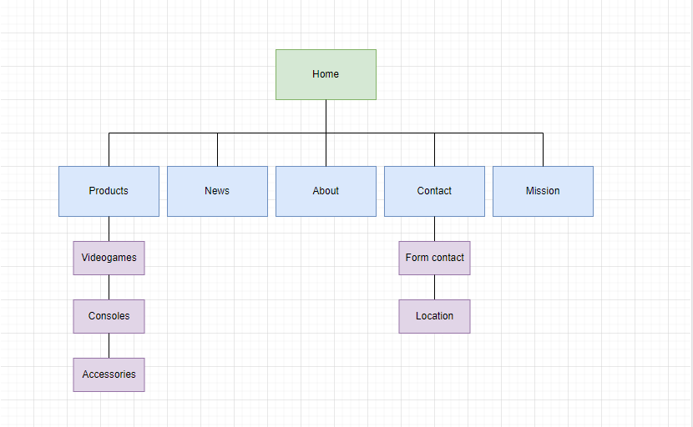***Sitemap***
2. ***Identity***

Our page logo:

This logo was created by the mix of the words: “game” and the letter “x” as I wanted to create a unique and “futuristic” name for the page also.

Branding elements:

* **Brand name**: “GameX”
* **Images**: The ones related to our products such as videogame covers, designs, concepts…etc.
* **Colour Scheme**: Purple (HEX: #B209B8) for navbar dropdown elements, Light Purple (HEX: #BC4ECA) for navbar elements hover, Black (HEX: #000000) for dropdown menu, Grey (HEX: #2E2E2E) for main container, Pink (HEX: #FFBCF7) for box shadows, Light grey (HEX: #A0A0A0) for the news boxes.
* **Typography**: 'Open Sans', 'Arial', sans-serif.
* **Slogan**: “As gamers, we understand your needs”

1. ***Wireframes***

* 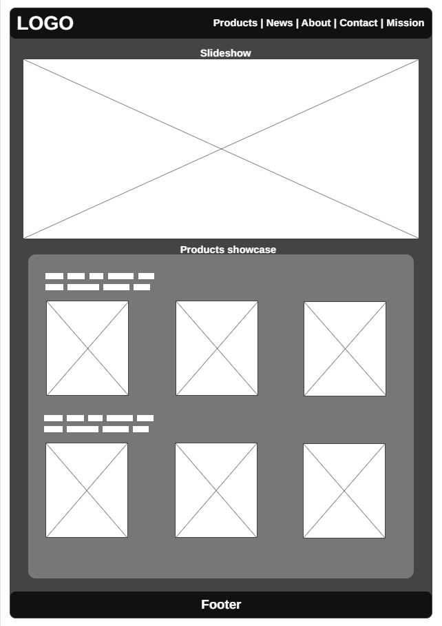Home Wireframe:
* 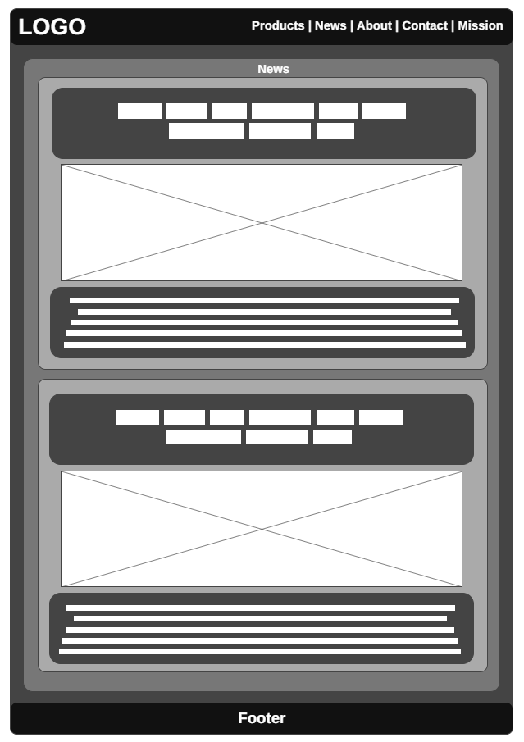News Wireframe:
* Products 🡪 Videogames Wireframe:

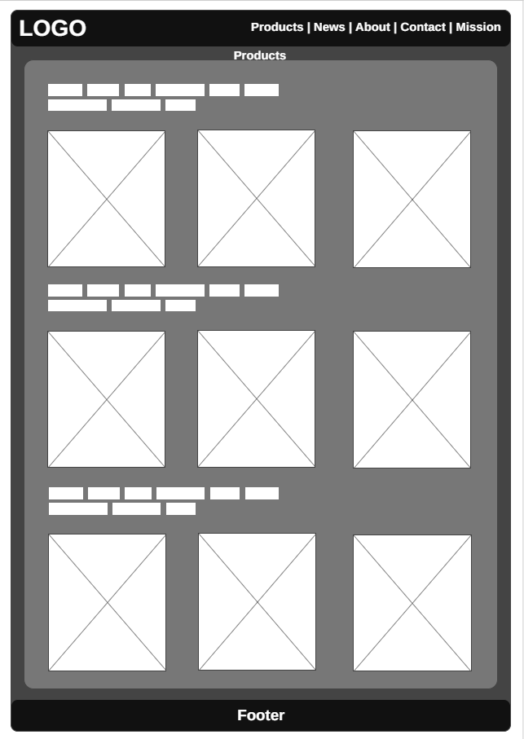

1. ***Design Comps***

Here are my three different variations of the graphic user interface:

* **Neon Green:**

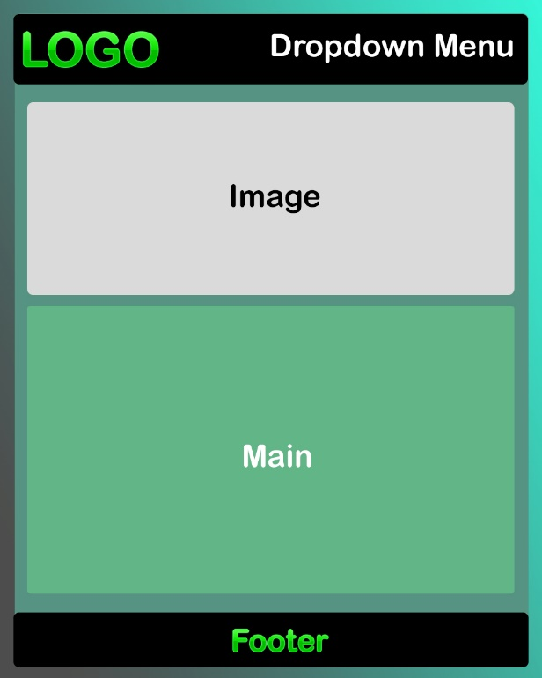**Home Page: News Page:**

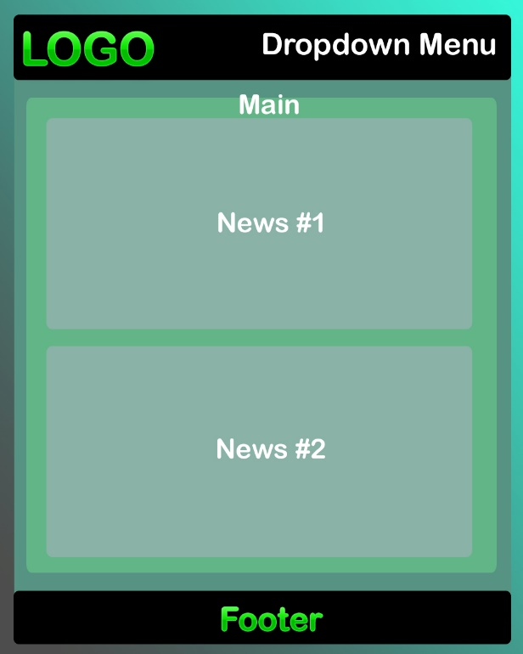

* **Neon Pink:**

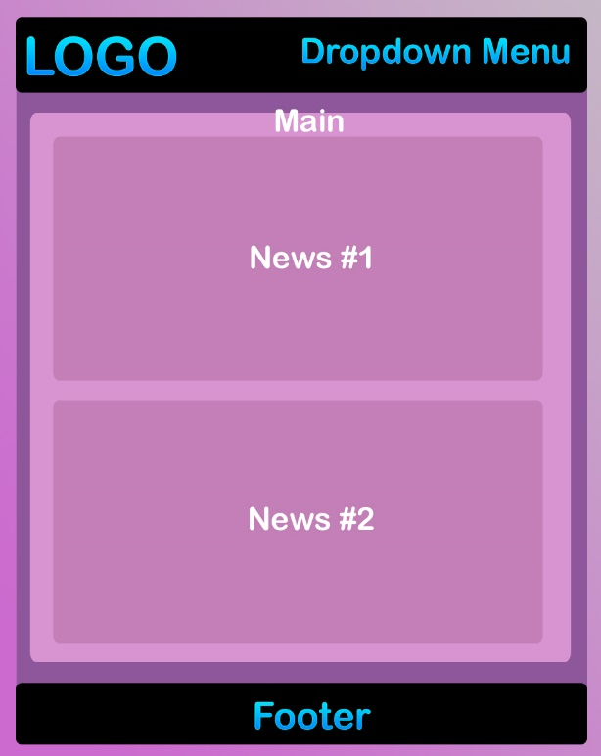**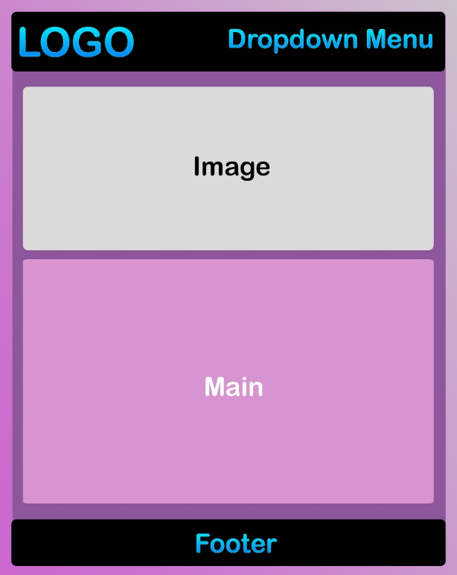Home Page: News Page:**

* **Neon Dark:**

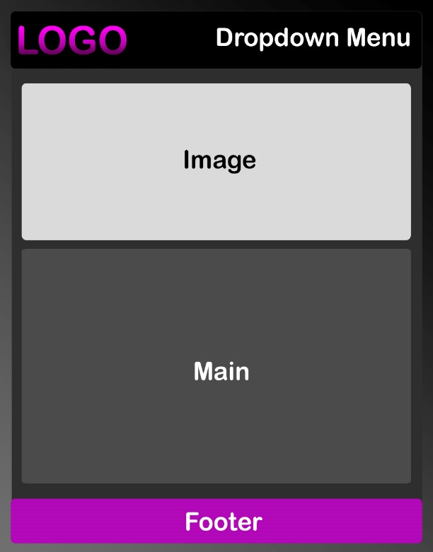**Home Page: News Page:**

